The Science Association,
B.K.Birla College, Kalyan

The Science Association of B.K.Birla College, Kalyan organized a number of activities in the academic year 2022-23 to promote science education and awareness among students.
20th February 2023
- Interview of Dr. Atish Dabholkar: In order to understand the origin of the Universe and black holes, the association organised a discussion on online interview of Dr. Atish Dabholkar, the Director of ICTP Italy. The interview was conducted by Dr. Parvez, a nuclear physicist and activist. Dr. Dabholkar gave a fascinating talk on the latest developments in cosmology and astrophysics. 50 students attended the session
- Project demonstrations: The association also organized project demonstrations where students got an opportunity to apply their knowledge and build their skills. They learned a lot when projects didn't work, as it gave them a chance to troubleshoot and figure out what went wrong. 55 students attended the session
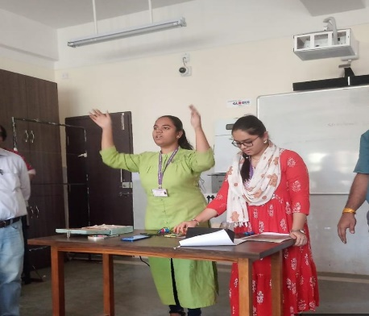
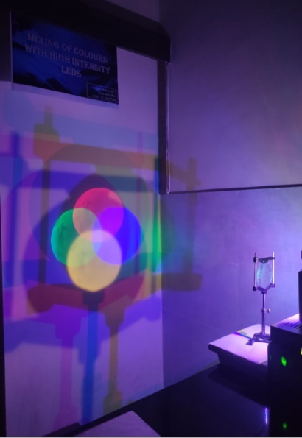

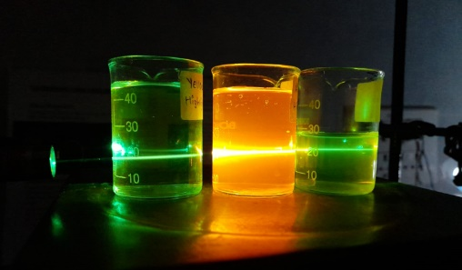

Project demonstrations

21th February 2023

- PowerPoint presentations: PowerPoint presentations were organized where students used tools like Geogebra and MATLAB to demonstrate three-dimensional vectors, crystal structures, and 3D plots. These presentations were very informative and helped students to visualize complex concepts. Sixty five students attended the session
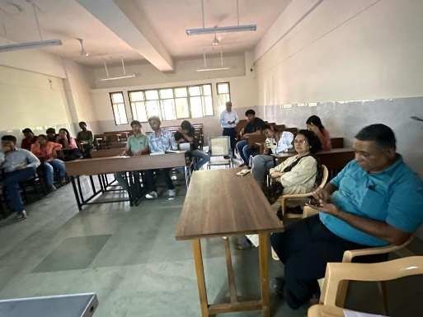

PowerPoint presentations

22th February 2023

- Scientific Rangoli competition: A competition of Scientific Rangoli was organized where students presented scientific themes through art. This activity helped to develop creativity and imagination. The rangolis were very impressive and showed the students' understanding of scientific concepts. sixty students attended the session

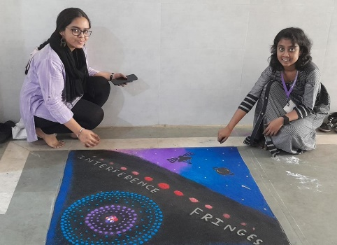
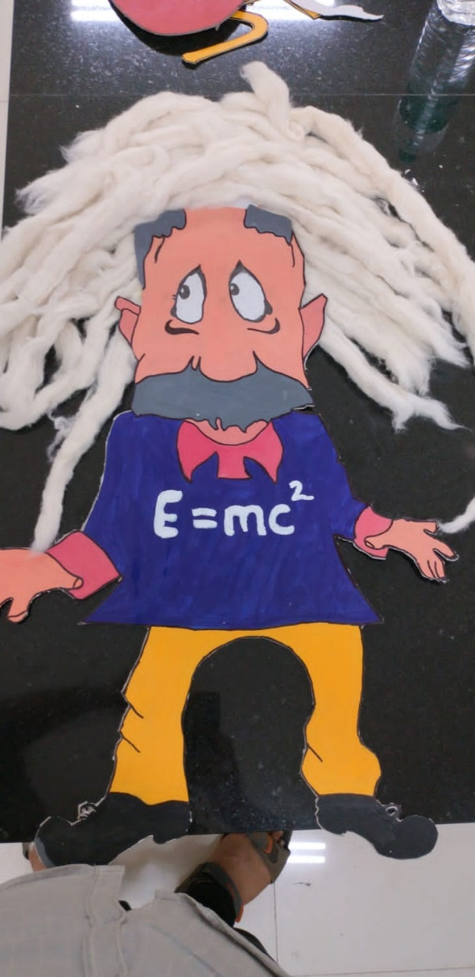

Scientific Rangoli competition

23th February 2023
- Scientific Meme competition: Science is also fun, and to promote science in a fun and engaging way, the association organized a Scientific Meme competition. The memes were very creative and funny, and they helped to spread awareness about science in a light-hearted way. Sixty five students attended the session

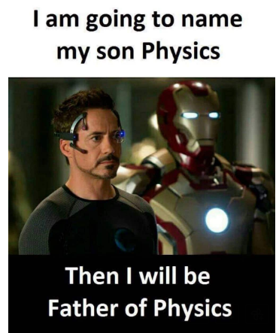

Scientific Meme

24th February 2023

- Visit to TIFR: In order to understand research conducted in various fields, the association organized a visit to TIFR and its various labs. Students got to see cutting-edge research in action and interact with scientists. This was a very enriching experience for the students. 15 students attended the session

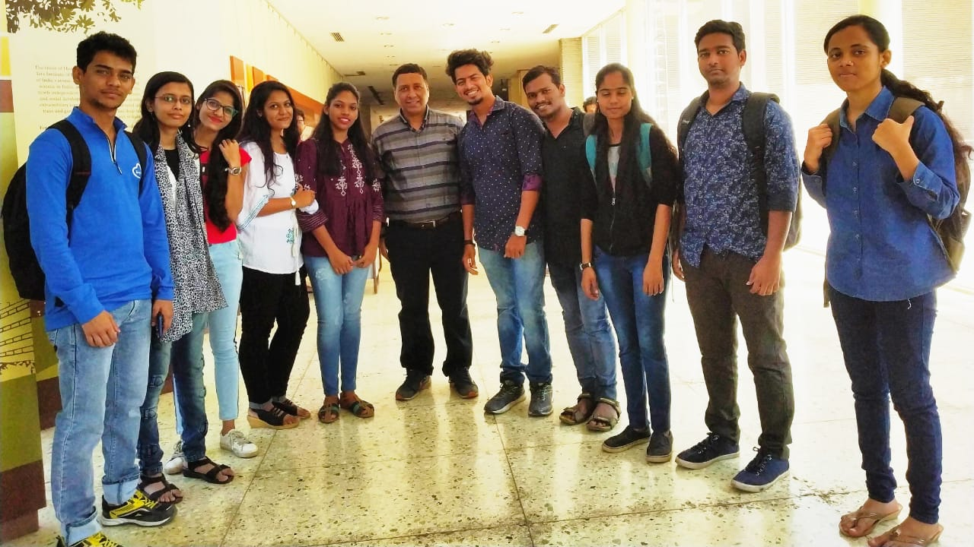
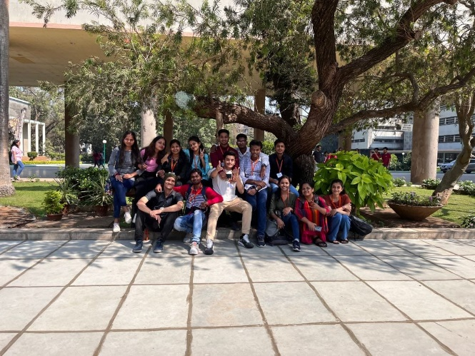
Visit to TIFR

