Report of Activities conducted by Science Association
(2021-22)

The Science Association conducted a variety of informative and engaging activities throughout the year 2021-2022. These activities helped students to learn about science and develop a scientific temper.

18 July 2021

Power Point Presentation Competition
A PowerPoint presentation competition was held on July 18, 2021. Students from all years participated in the competition. They presented presentations on a variety of scientific topics, such as climate change, renewable energy, and artificial intelligence. The presentations were judged by a panel of experienced scientists and educators. The winners of the competition were awarded prizes. Sixty students, including volunteers from the Science Association, and ten teachers attended the program above.
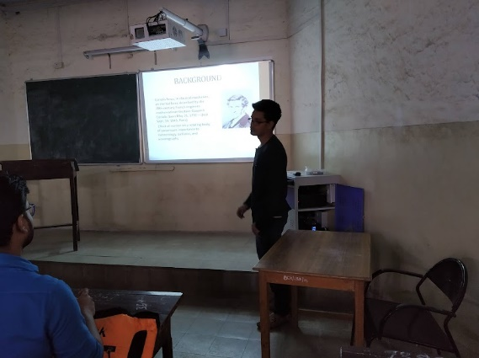

Power Point Presentation Competition (18 July 2021)

September 23, 2021

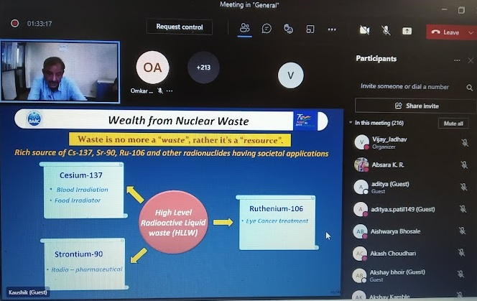
The Science Association was inaugurated on September 23, 2021, with Dr. C. P. Kaushik, Group Director, Nuclear Recycle Group BARC, Mumbai, as the chief guest. Dr. Kaushik spoke about the importance of science and technology in modern society and encouraged students to pursue careers in science. He , gave a talk on the topic of "Challenges and Innovation in the field of radioactive waste". Her talk was informative and engaging, and students learned a lot about the challenges and innovations in the field of radioactive waste management. Fifty students, including volunteers from the Science Association, and seven teachers attended the program above

December 30, 2021.

Visit to BARC
To document the visit of three teachers to the Bhabha Atomic Research Centre (BARC) on December 30, 2021.

Visitors:
Dr. Madhavi Thakurdesai, Head of the Department of Physics
Dr. Vijay Jadhav, Associate Professor
Dr. Harishkumar Dubey, Principal of B.K. Birla Night College
Arrival and Departure:

The teachers met by a BARC representative who escorted them to the BARC Visitor Center. After completing the necessary formalities, the visitors were given a tour of the BARC campus. The tour included visits to the following facilities:
The BARC Museum
The BARC Library
The BARC Nuclear waste division
TheTeachers departed from BARC at 5:00 PM on the same day.

Observations:

The Teachers were impressed by the scale and scope of BARC's research and development activities. They were particularly interested in the BARC Reactor Complex, which houses a variety of nuclear reactors used for research, power generation, and isotope production. The Teachers also appreciated the opportunity to learn about the latest advances in nuclear medicine at the BARC Nuclear Medicine Center.

Photography is not allowed in BARC

25 February 2022

Webinar on Spectroscopy of Raman active molecules
A webinar on the topic of "Spectroscopy of Raman active molecules" was held on February 25, 2022. The webinar was conducted by Dr. Vasnt Sathe, Centre Director, UGC DAE Consortium for Scientific Research, Indore. Dr. Sathe discussed the basics of Raman spectroscopy and its applications in various fields, such as chemistry, physics, and biology. The webinar was informative and engaging, and students learned a lot about Raman spectroscopy and its potential applications. Forty eight students were present for this program
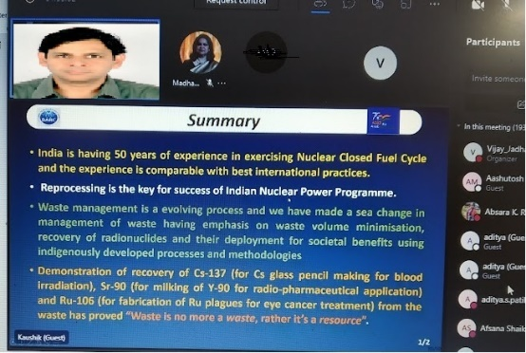

Webinar on Spectroscopy of Raman active molecules. 25 Feb,2022
28 February 2022

National Level Scientific Quiz Competition(Online)
A National Level Scientific Quiz Competition was held on February 28, 2022. Students from all over India participated in the competition. The competition was divided into two categories: Junior College (Class XI-XII) and Senior Category (FYBSc-TYBSc.). The winners of the competition were awarded prizes.
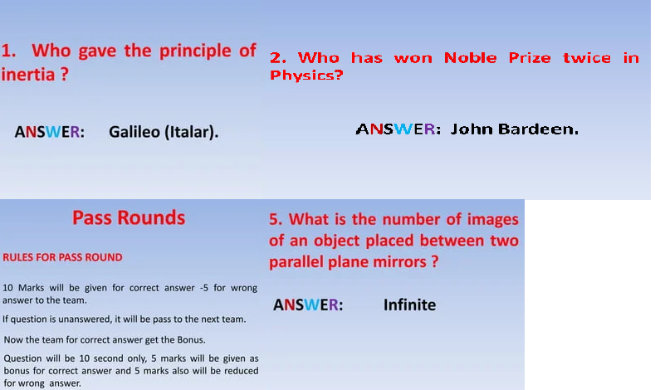
National Level Scientific Quiz Competition (Online)

24 December 2021

Sky Observation ( Bapgoan, Kalyan)
A sky observation session was held on December 24, 2021. Students from the Science Association had the opportunity to observe the night sky through telescopes. They also had the opportunity to learn about the different planets, stars, and other celestial objects in the night sky.15 students were present in this activity
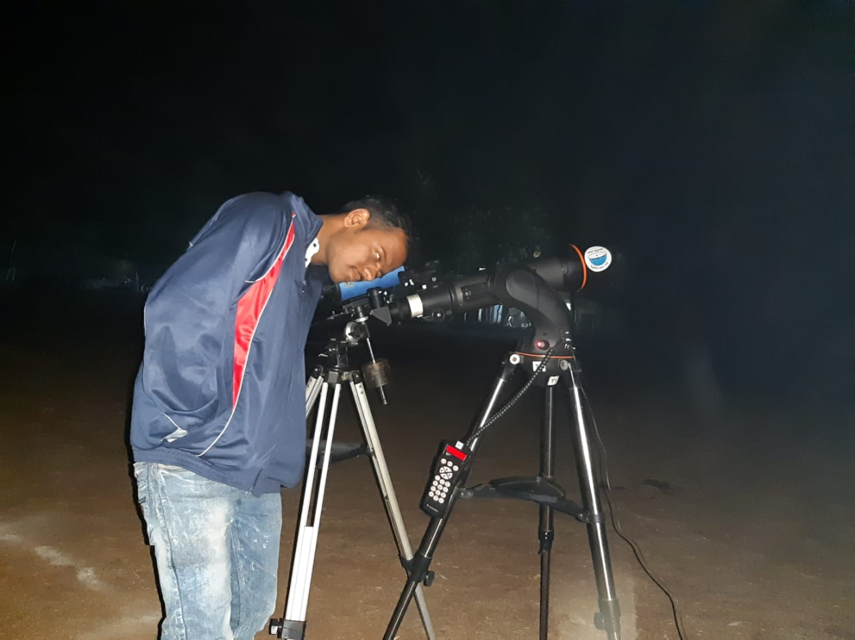

Sky Observation (24 December 2021)

cience Day is celebrated on February 28 every year in India to commemorate the discovery of the Raman Effect by Indian physicist Sir C. V. Raman on this day in 1928. The Raman Effect is a scattering of light that occurs when a photon of light strikes a molecule. It is responsible for the colors of the sky and the ocean.

Lecture:

Dr. Sharad Kasarle Sir, CEO of DSK Nutrition Research Centre, Mumbai, gave a lecture on various health plans and healthy food and remedy on cancers like diseases. He talked about the importance of eating a healthy diet and exercising regularly to maintain good health. He also discussed the importance of early detection and treatment of cancer.

Health Plans:

Dr. Kasarle Sir discussed a variety of health plans that can help people stay healthy. He talked about the importance of having a regular check-up with a doctor, getting vaccinated, and eating a healthy diet. He also discussed the importance of exercising regularly and managing stress.

Healthy Food and Remedy on Cancers Like Diseases:

Dr. Kasarle Sir discussed a variety of healthy foods that can help people reduce their risk of developing cancer. He talked about the importance of eating plenty of fruits, vegetables, and whole grains. He also discussed the importance of limiting processed foods, red meat, and sugary drinks.

Dr. Kasarle Sir also discussed a variety of remedies that can help people prevent and treat cancer. He talked about the importance of getting enough sleep, managing stress, and avoiding smoking and secondhand smoke. He also discussed the importance of early detection and treatment of cancer. One hundred and seven students attended the lecture
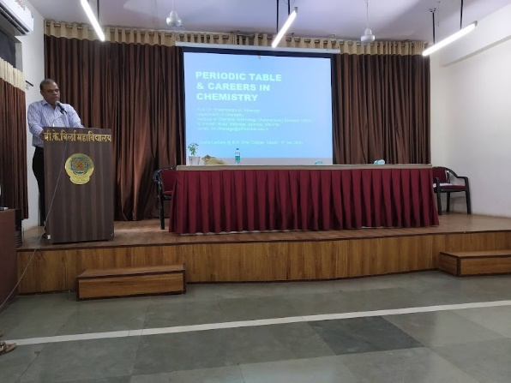

Dr. Sharad Kasarle Sir, CEO of DSK Nutrition Research Centre, Mumbai

