Report on Activities conducted by Science Association
(2019-20)

20.11.2019

Workshop on “Building scientific temper”
To inculcate scientific temper in students, the Department of Physics and Science Association jointly organized a workshop on "Building Scientific Temper" on November 29, 2019, under the DBT Star status. Dr. Aniket Sule and Dr. Rohini Karandikar, Scientists at the Homi Bhabha Science Center, TIFR, Mumbai, conducted the workshop.
In the workshop, students were given situations to analyze scientifically. Based on their analysis, they were introduced to rational thinking and taught the scientific method to analyze any situation rationally. Students were also taught how to get away from superstitions and blind beliefs. The workshop included demonstrations to show how superstitions and blind beliefs can be harmful.. Sixty students, including volunteers from the Science Association, and twelve teachers attended the program .
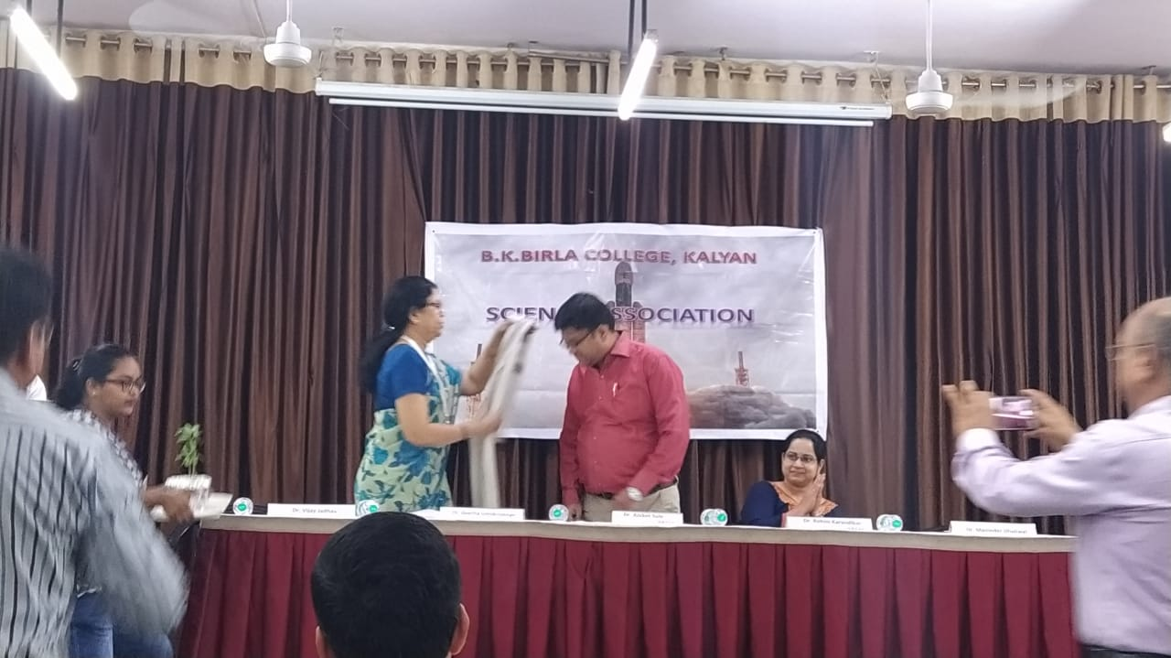
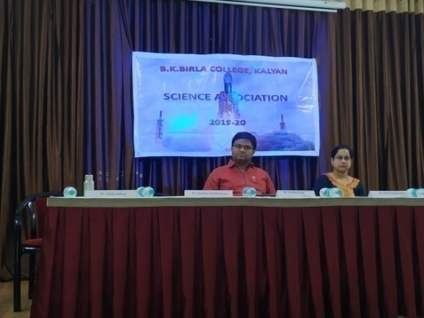

Workshop on “Building scientific temper”

05.12.2019

Workshop on fascinating experiments in science
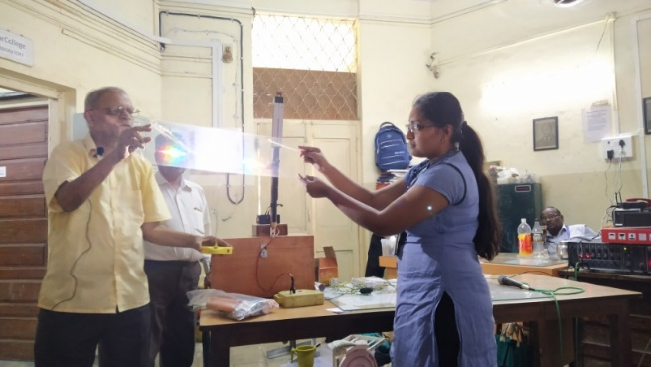
This workshop was organized to give students an opportunity to learn about and perform some fascinating science experiments. Students learned about a variety of scientific concepts, such as gravity, electricity, and magnetism, through these experiments. The workshop was led by Mr.Bhagawan Chakradev and two experienced science teachers. Hundred and six students, including volunteers from the Science Association, and ten teachers attended the program
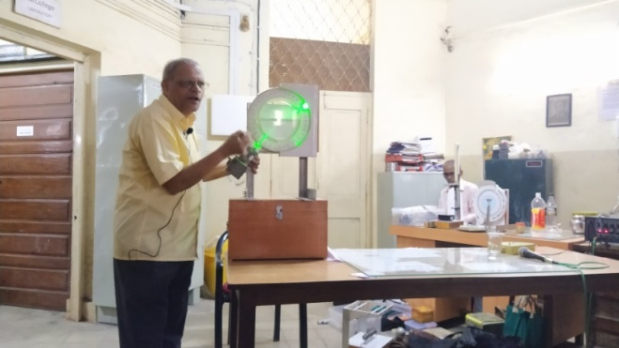
Workshop on fascinating experiments in science

04.01.2020
Special Lecture by Dr. Bhanage, Professor, ICT Mumbai
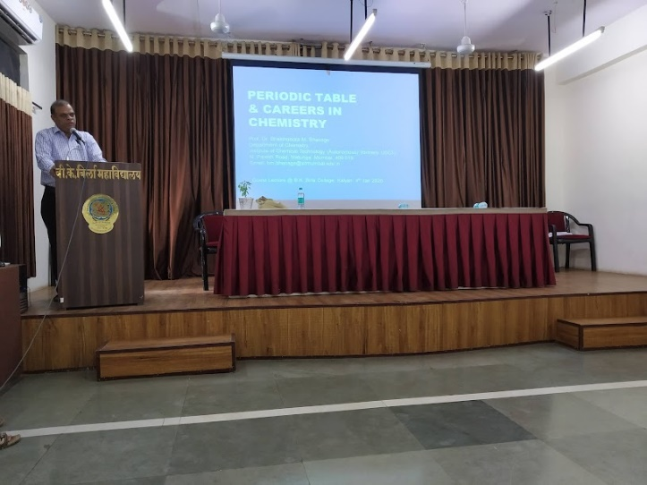
Dr. Bhanage delivered a special lecture on the topic of the periodic table. He discussed the history of the periodic table and its importance in chemistry. He also explained the different elements of the periodic table and their properties. The lecture was informative and engaging, and students learned a lot about the periodic table. Sixty students, including volunteers from the Science Association, and twelve teachers attended the program

Special Lecture by Dr. Bhanage, Professor, ICT Mumbai
science

28.02.2020

Celebration of Science Day
The Science Association celebrated Science Day on February 28, 2020. The event was inaugurated by Dr. M Aslam, Professor, IIT Mumbai. Dr. Aslam delivered a lecture on the importance of science and technology in modern society. He also encouraged students to pursue careers in science and technology. Sixtyfive students, including volunteers from the Science Association, and twelve teachers attended the program
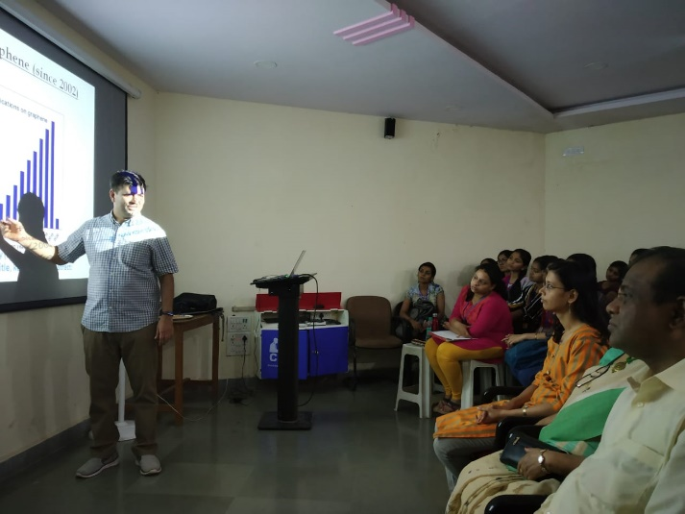

Celebration of Science Day
science

Poster Presentation
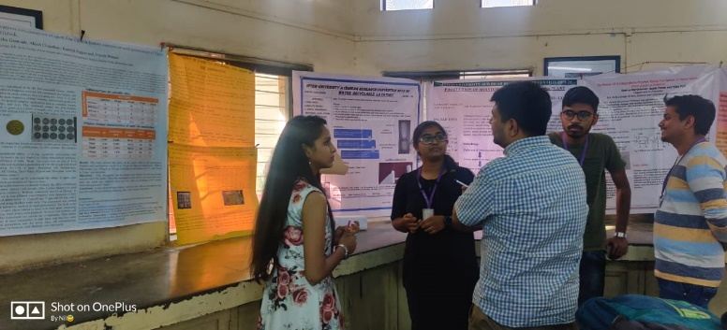
A poster presentation competition was held as part of the Science Day celebrations. Students from all years participated in the competition. They presented posters on a variety of scientific topics, such as climate change, renewable energy, and artificial intelligence. The posters were judged by Dr.Aslam and Dr.Madhavi Thakurdesai. The winners of the competition were awarded prizes.There were twenty two posters in the competition
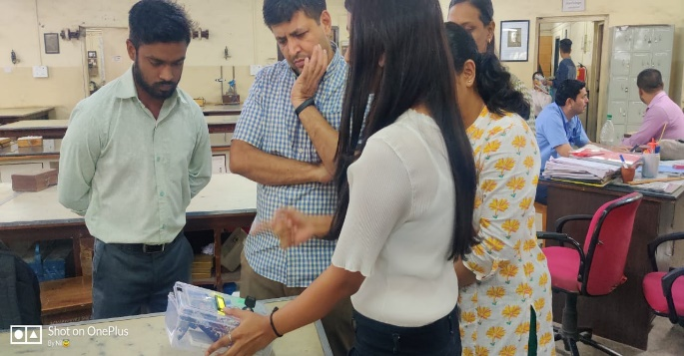
Poster Presentation,Science Day
science

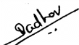
Dr.Vijay Jadhav
Chairman, Science Association

